


Emergency
First Aid
at Work + AED
Handbook

Singleton
Training

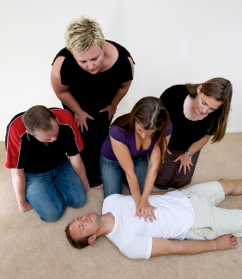

Contact the Office on 01522 300161

www.singleton-associates.org



FIRST AID

The main purpose of first aid is to preserve life, promote recovery and prevent the condition from getting worse.

Safety

Our main concern as an emergency first aider is to take control of the situation. STAY CALM!
This includes ensuring the area is safe for first aid to be practiced.
If the area is not safe the emergency first aider should seek expert help to make the scene safe, unless they are capable of making it safe themselves.

Initial assessment

Once the area is safe, we need to assess ALL casualties for signs of life:

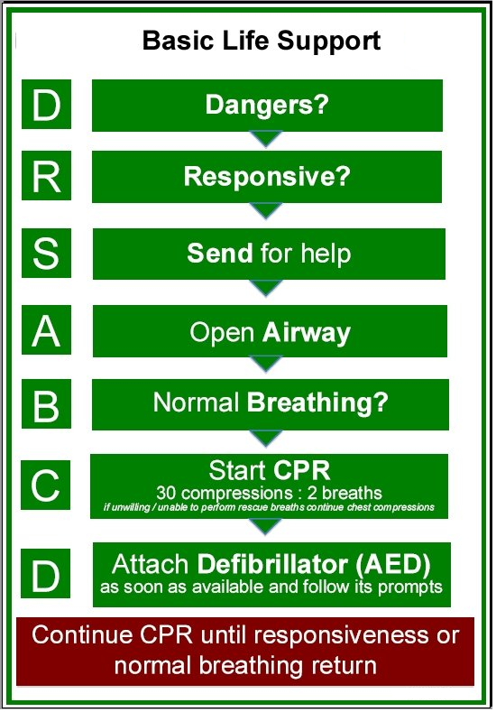
Singleton
Associates
SECONDARY ASSESSMENT

- Shake gently and seek verbal response,
- Talk to the casualty - tell them what you are doing,
- Open the airway,
- Check for breathing,
- Check for colour or signs of life,
- If casualty has ABC check for list below,
- Check for medical clues - talisman etc.,
- Check top to toe for serious fractures,
- Check for swelling,
- Check for bleeding,
- If airway deteriorates place in recovery position.

RECOVERY POSITION

If casualty has difficulty breathing at initial ABC check, turn into recovery position, regardless of other injuries.

If the casualty has no serious injuries after top to toe, turn into recovery position.



CPR

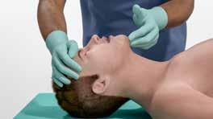

CHECK MOUTH & OPEN THE AIRWAY



CHECK FOR BREATHING (10 SECS)
IF NO NORMAL BREATHING START CPR

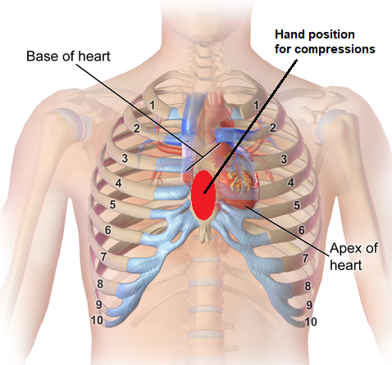

POSITION FOR COMPRESSIONS

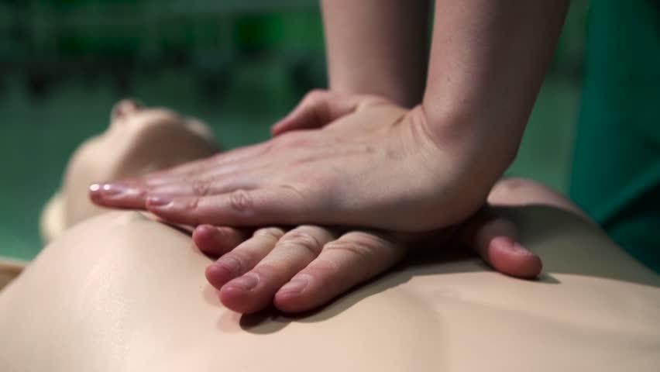

PRESS 30 TIMES (5cm depth)
AT RATE OF 100-120 PER MINUTE
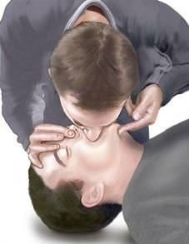
Singleton
Associates

BLOW IN TILL CHEST MOVES
REPEAT AFTER 1 SECOND

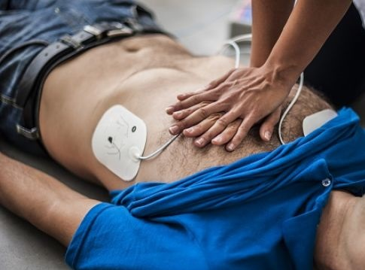

CONTINUE USING 30:2 RATIO UNTIL AED ARRIVES
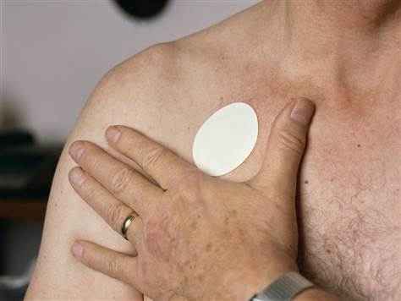

Beware of medication patches

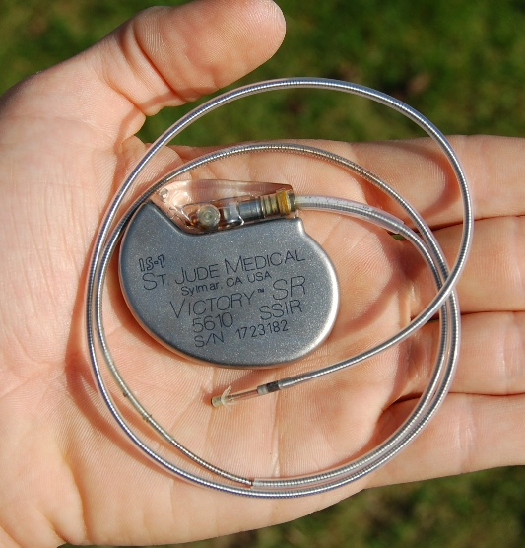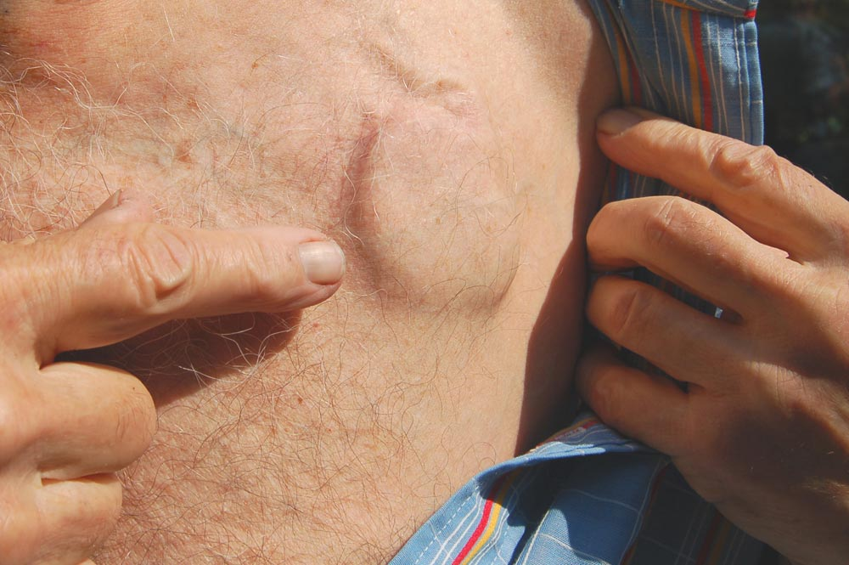

Beware of implanted pacemakers

Chest will need to be dry (use a towel) and not have excessive chest hair (use the razor).

Spare pads, towel, razor, and if possible, a spare battery should be kept with the AED or in the case for the AED

Only apply an AED if casualty is NOT breathing normally!

- Take AED to casualty
- Switch on AED
- Stick one pad to casualty’s upper right bare chest
- Stick other pad to lower left bare chest
- Follow instructions from AED

Immediately resume CPR once shock delivered.
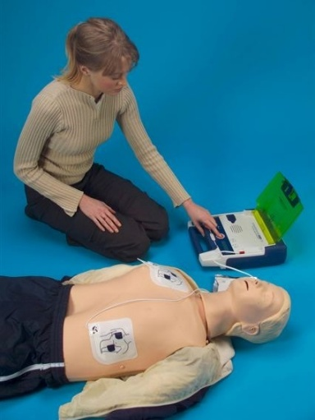
- Fill in Accident Book
- Report to RIDDOR
- Download data to a PC

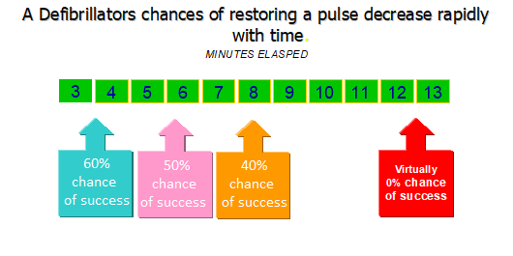

Fainting

Treat as an unconscious casualty - place in the recovery position and then identify and treat the cause of the faint. If the situation is not corrected the casualty is unlikely to regain consciousness.

Head Injury

Cold compress such as wet towel or frozen food wrapped up in towel for lumps and bumps.
No pressure covering for indentations / fractures, it is very important to completely immobilise the head if a fracture is suspected. Symptoms may include fluid coming from the ears, eyes or nose; this fluid is cerebro-spinal fluid that is leaking from the brain cavity.

Stroke

Conduct FAST test:

Facial weakness
Arm weakness
Speech problems
Time to call for help – 999/112

Monitor casualty at all times

Asphyxia

Remove from source of asphyxiation if safe to do so. If asphyxiation is caused by item remove item and check for ABC; be prepared to resuscitate.

Heart Attack

Chest pain like indigestion, skin pale and lips blue, breathless with profuse sweating, rapid pulse which becomes weaker and may stop, pain radiating down left arm and upwards towards shoulder and jaw.
Sit down to minimise work of heart.
GET HELP IMMEDIATELY
Get casualty to chew an aspirin
Complete ABC if necessary and be prepared to resuscitate.

Angina

Chest pains spreading to left arm, skin pale and lips blue, short of breath and feeling weak, usually following physical exercise.
Rest casualty to allow symptoms to subside and check for medication. First aiders should assist casualty to take their medication such as GTN.

Poisoning

Corrosive - do not induce vomiting; give water ONLY, to dilute.
Poisons - allow vomiting, nil by mouth, do not move as this increases metabolism.
Call 999
Send sample or container with casualty.

Epilepsy

Violent muscle convulsions leading to biting of tongue, cheek or lips. Safeguard yourself first.
Remove obstacles if safe. Never put anything in mouth. Treat any injuries sustained after attack.
Call ambulance if hurt or it is their first seizure.
If seizure lasts longer than 5 minutes or if one seizure leads straight into another one GET HELP. Continued seizures may cause lack of oxygen to the brain.

Diabetes

HYPO - Casualty may appear aggressive (drunk) and has excessive sweating and shivering.

HYPER - Skin pale, rapid pulse, thirsty breath smells of pear drops.

For both conditions, the first aid treatment is to give sugar and monitor response.
If condition does not improve – GET HELP

Anaphylaxis

The signs and symptoms associated with anaphylactic shock include:

- Weak tachycardia
- Swelling of the face and possibly the tongue
- Urticarial rash
- Dyspnoea (air hunger)
- Pale, cold and clammy skin
- Possible cyanosis
- Weakness, dizziness, nausea, vomiting
- Thirst and dry mouth
- Altered level of consciousness
- Gastrointestinal upset

Management of Anaphylactic Shock

- Ensure ABC and ventilate if necessary
- Administer oxygen via a non-rebreathing mask
- Lay the patient down flat with legs raised
- Loosen tight or restrictive clothing
- Get any history of previous anaphylactic reactions
- Monitor and record vital signs
- Use the patient's own auto injector (epi-pen or similar)
- Transport to hospital urgently
- If first epi-pen does not work, give second epi-pen if available after 10 minutes

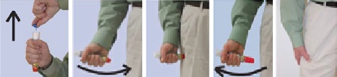

Bleeding

Wear gloves if possible
Do not remove embedded objects

Sit or lay casualty down
Examine wound - Do not remove embedded objects
Elevate wound to allow gravity to slow bleeding
Press directly on the wound to stop bleeding

If bleeding does not stop apply second dressing over the top of the first or consider applying a tourniquet

Burns

Cold water for minimum of 10 minutes and 20 mins for a chemical burn.

The main treatment is to stop the wound from burning any further and causing more damage.

Remove jewellery in case skin swells. Do not apply creams/sprays

If burn is deep or covers an area greater than the palm of the casualty’s hand, immediately dial 999.

Fractures

Types of fracture

- Closed
- Open
- Comminuted (Compound)
- Greenstick
- Stress

Signs & symptoms

- Pain
- Loss of power
- Unnatural movement
- Swelling / bruising
- Deformity
- Irregularity
- Crepitus
- Tenderness

Treatment

- Do not attempt to bandage
- Do not attempt to move the limb in any way
- Do not give anything to eat or drink

- Do Steady and support the affected area
- Do Protect the affected area with padding
- Do send to hospital

Health & Safety (First Aid) Regulations 1981

An employer shall provide such equipment and facilities as are adequate and appropriate in the circumstances to enable first aid to be rendered.
------------
This is achieved by reviewing the accident book, the size of the premises, the number of employees and the seriousness of the accidents.

Risk | First Aid Boxes | Appointed person | Emergency first aider | First aider | First aid room
Low (Office) |  |  | 
Medium (restaurant) |  |  |  | 
High (Factory) |  |  |  |  | 

Accident Books

- All accidents should be recorded
- Allows causes of accidents to be highlighted
- Legal requirement
- Covers employer against fraudulent claims

Contents of First Aid Box (1-10 persons)

Suggested HSE contents:

- Guidance card
- Selection of individually wrapped plasters (40)
- Eye pads (2)
- Some form of bandage fastener (safety pins) (6)
- Triangular bandages (2)
- Medium sterile unmedicated dressings (2)
- Large sterile unmedicated dressings (2)
- Disposable nitrile gloves (6 pairs)
- Sterile wipes (20)

BS 8599-1(2019) additions

  - Micropore tape 2.5cm x 10m
  - Finger dressing 3.5 x 3.5cm (2)
  - Face Shield
  - Space blanket
  - Tuff-kut shears
  - Conforming bandage 7.5cm x 4.5m
  - Burn dressing

Other items may be added if deemed necessary after an assessment of need.

Generally, lotions, ointments, sprays, creams and medication are not permitted unless the first aiders have had specific training on the administration of these items.

Singleton
Associates
Handing over to a Paramedic

This is a list of things a Paramedic would want to know at handover of a casualty.

- I - Identification of patient
- M - Mechanism of injury or Medical complaint
- I - Injuries or Information related to complaint
- S - Signs and Symptoms
- T - Treatment and Trends

- A - Allergies
- M - Medication
- B - Background
- O - Other information
Other courses we offer include:

First Aid at Work

First Aid for Mental Health

Basic Food Hygiene

Intermediate Food Hygiene

Advanced Food Hygiene

Basic Health & Safety

Intermediate Health & Safety

COSHH

Manual Handling

Risk Assessment

We also offer

Event medical cover

1st aid supplies

For details of our quality assurance, please visit our web site:

http://www.singleton-associates.org/services/quality-assurance/

The Training Hub, Unit 14, Deacon Road Business Park, Lincoln. LN2 4JB

